Leo Chai

Mrs. Goldenberg E.

ETS4UA-02

2019-10-24

Rationale

I chose to write a journal on Crunchyroll’s news panel to investigate how translation takes away meaning from a text. My goal is to demonstrate how language is interpreted differently in different cultural contexts, and how meaning is lost in translation.

I will be talking about a TV anime series called “Monogatari”. It is about the protagonist Araragi helping others who suffer from supernatural monsters. These series have achieved a huge financial success and massive popularity in Japan, but lacks interest in the west.

I will be analyzing how the strategic use of Japanese cultural aspects such as kanji and allusions to the religion system enhances the anime, and how a lack of cultural context takes away meanings. I will connect these points to the massive difference in the popularity of “Monogatari” in Japan and the west.

I will be creating an online article on the anime website “Crunchyroll”, which is an anime service providing a website that provides streaming service as well as articles on anime. Since my audience is anime fans looking for a new anime to watch, putting my article on this popular anime website will attract them to read my article.

Having my text on Crunchyroll also allows me to use a variety of screenshots of the anime to show examples of what I am talking about. Since anime is a graphical medium, having images will help my audience understand my analysis better.

People who go on Crunchyroll also are likely to have watched multiple anime, as Crunchyroll is a paid service, and thus would have some knowledge about the Japanese religion system and kanji. These contexts are important because they are key parts to my arguments and understanding of these contexts would make my text easier to understand.

Word Count: 290

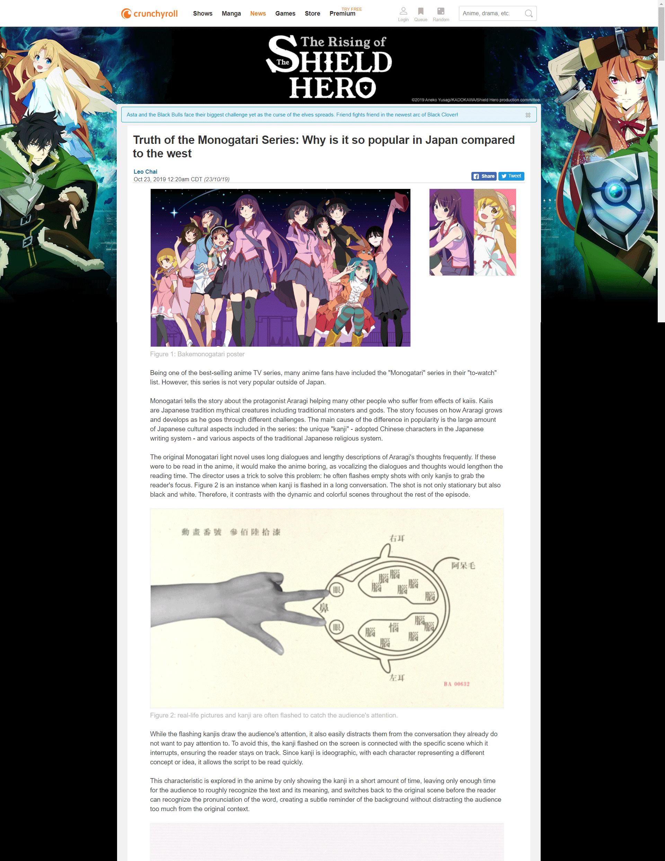

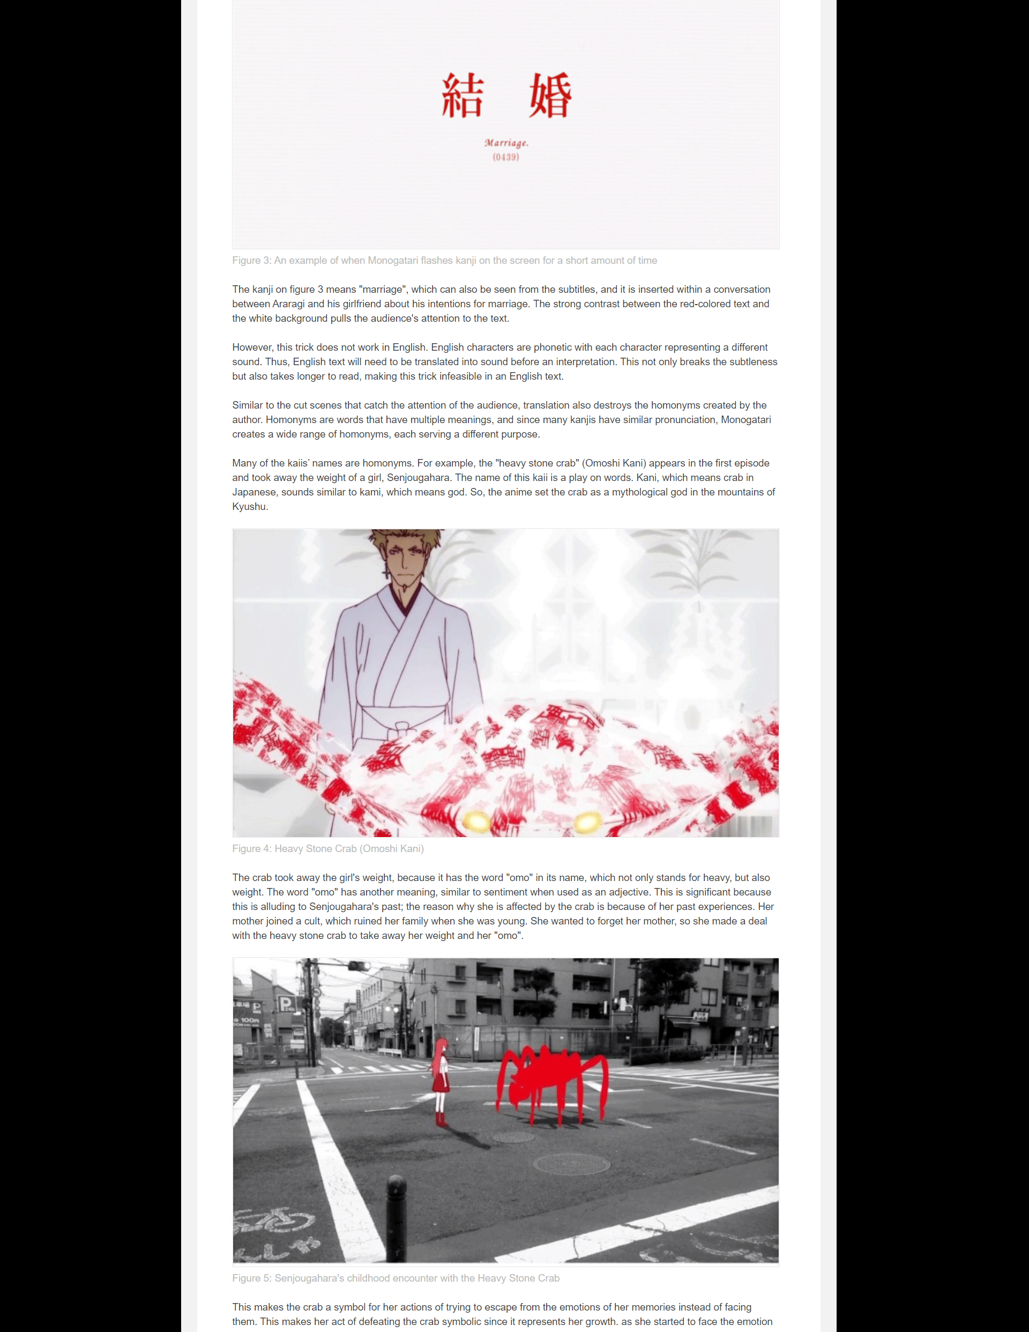

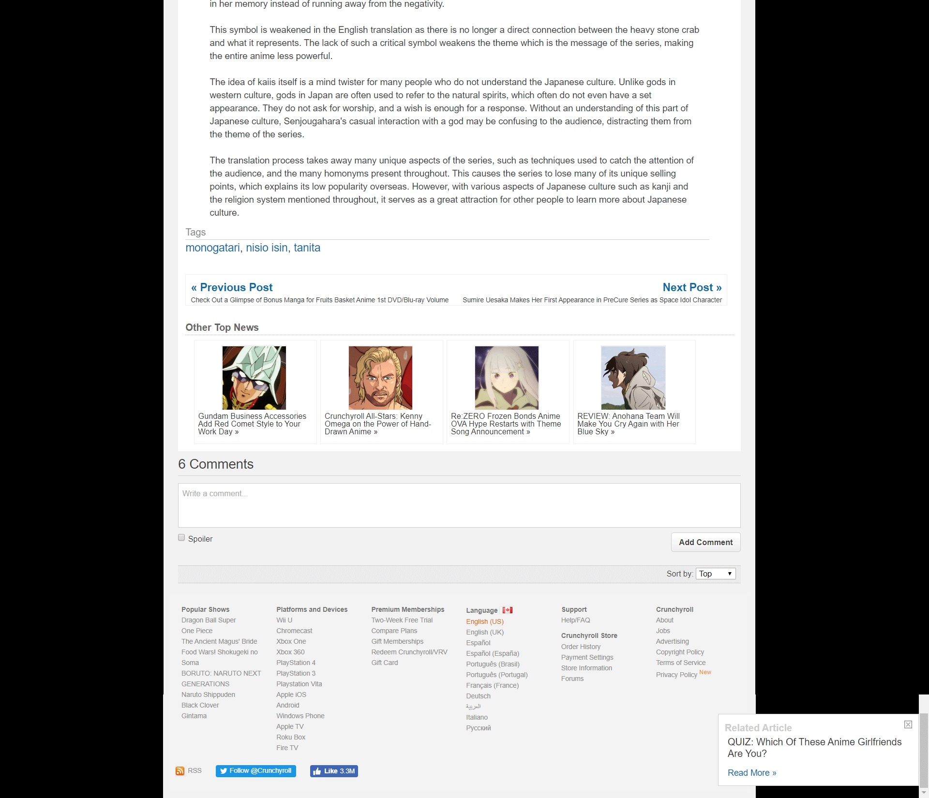

Word Count: 992

Work Cited

Shinbo, Akiyuki, director. *Bakemonogatari*. *Bakemonogatari*, Shaft, 2009.

Komatsu, Mikikazu. “Monogatari Anime Series Celebrates Its 10th Anniversary with Custom Body Composition Monitor.” *Crunchyroll News*, Crunchyroll, 23 Oct. 2019, https://www.crunchyroll.com/anime-news/2019/05/10-1/monogatari-anime-series-celebrates-its-10th-anniversary-with-custom-body-composition-monitor.

“The Best Selling Anime from 2000-2014 (Blu-Ray/DVD).” *MyAnimeList.net*, My Anime List, 13 Mar. 2016, https://myanimelist.net/featured/1496/The_Best_Selling_Anime_from_2000-2014_Blu-ray_DVD.